- Pages:
  - Homepage
  - How it Works
  - Services
  - Portfolio
    - Our Work
    - Testimonials
  - Articles
    - Blog
    - News
  - FAQ
  - About Us
  - Contact Us

Homepage – This is the landing page. We do not want much information on it. Just the logo and the shape with the hyperlinks.
- Octagon in the middle of the page with electrical circuits design
  - Logo in the center
  - Each page is at the corner of an octagon with the hyperlink
Example of the design:

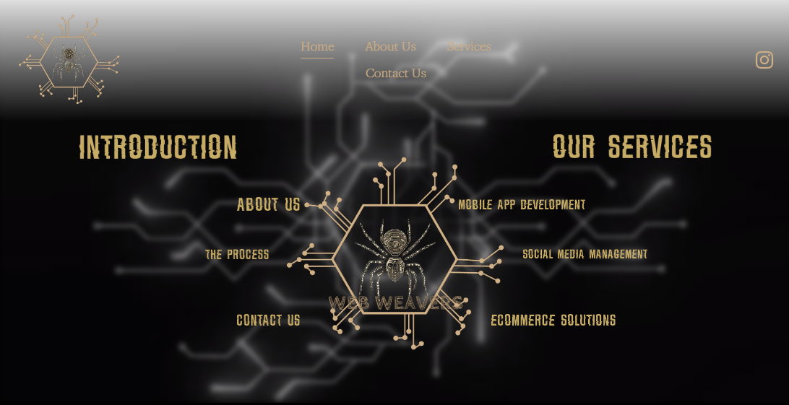

How it Works Page – The page will have an image at the top with the quote “Six Steps to Success”
Each phase should have an electrical circuit that connects the steps from left to right, moving slightly downwards.
Example of the design:
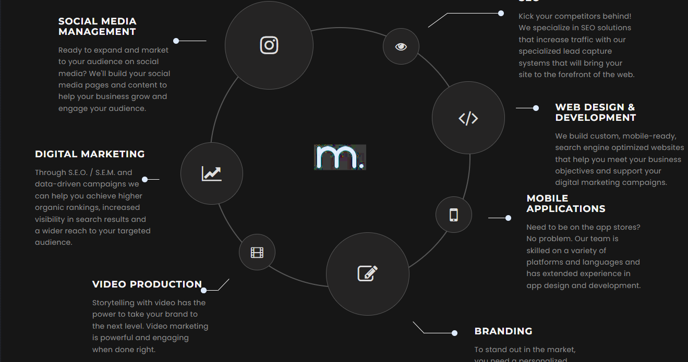
- Discovery Call
- Agreement
- Research and Setup
- Design & Development
- Quality Assurance
- Finalization & Deployment

Services Page – A bubble for each service (squares with rounded corners)
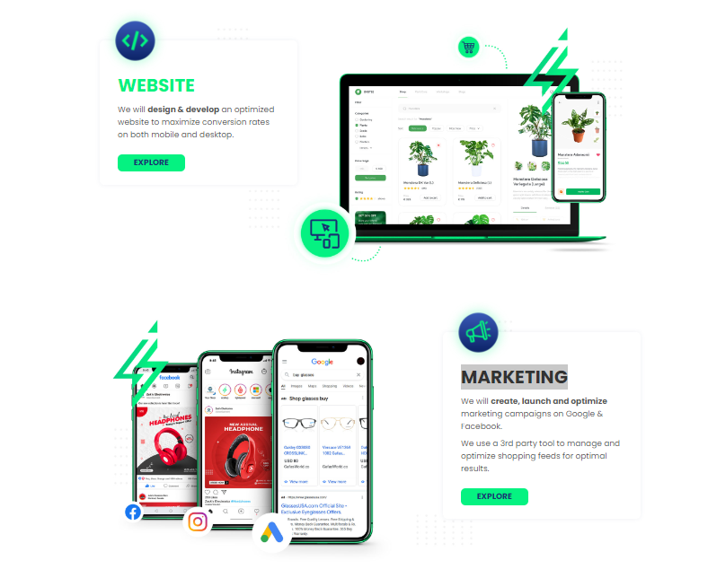
- Website Development
- Mobile App Development
- Digital Marketing
- SEO
- Social Media Management

Portfolio Page – Stick to the theme of electrical circuits and spiderweb design
- Our work + Reviews on the same page but with a separation. We need squares/space to adjust these manually when we want.

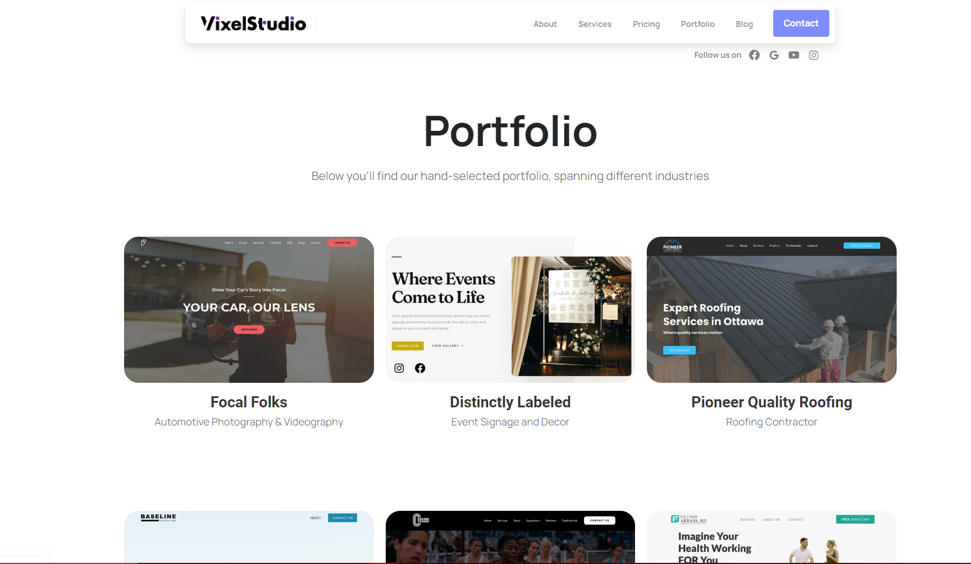

Articles Page – Stick to the theme of electrical circuits, but this is an example of the set up.
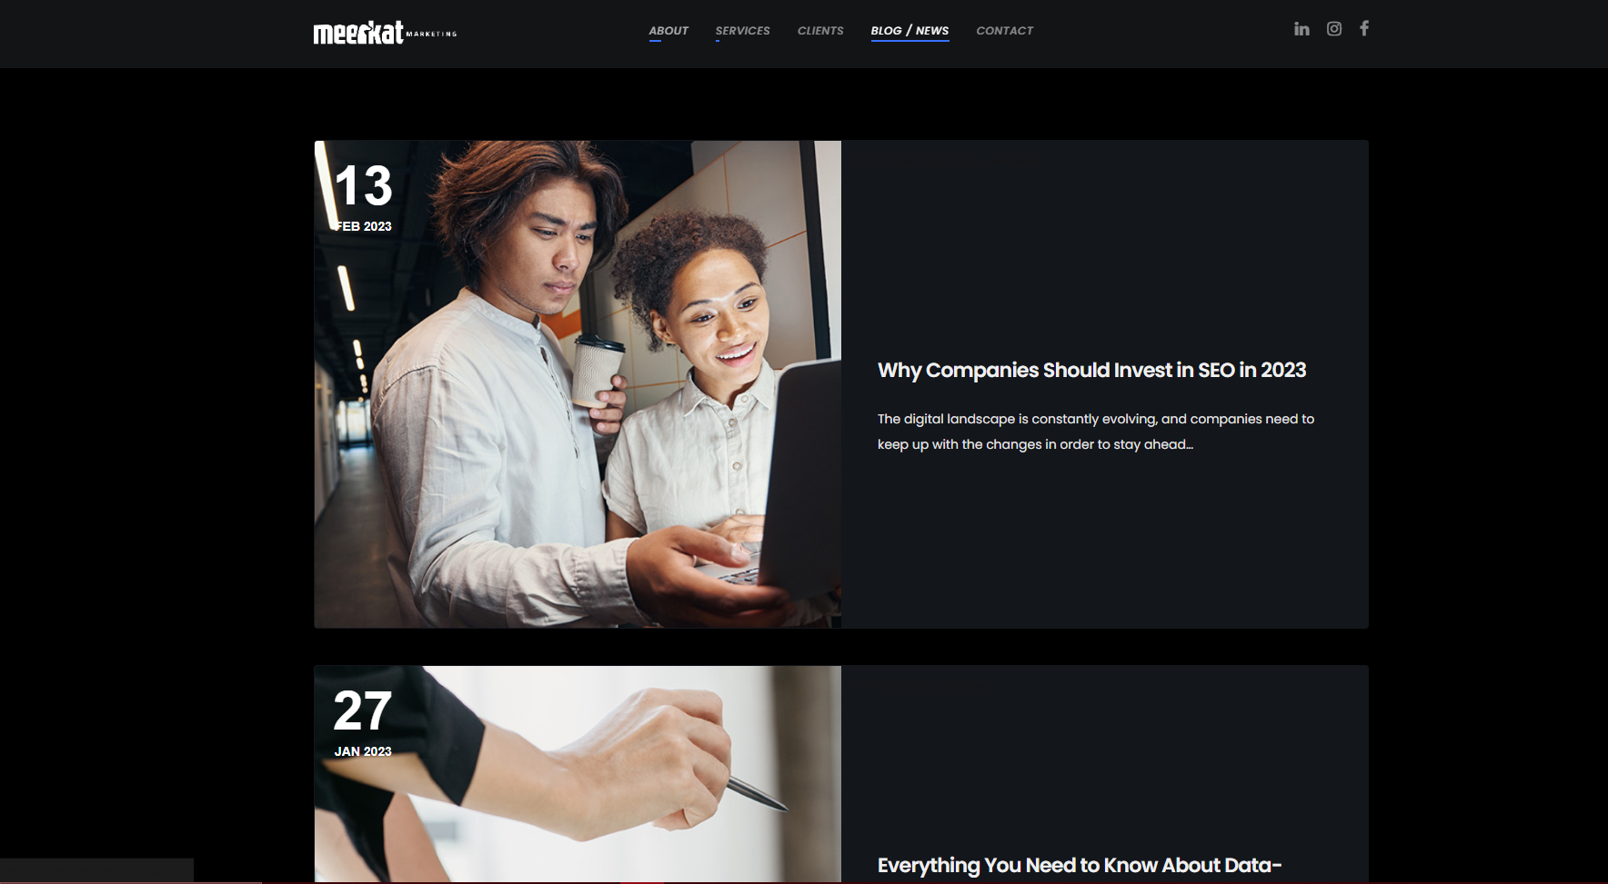

About Us – Example page
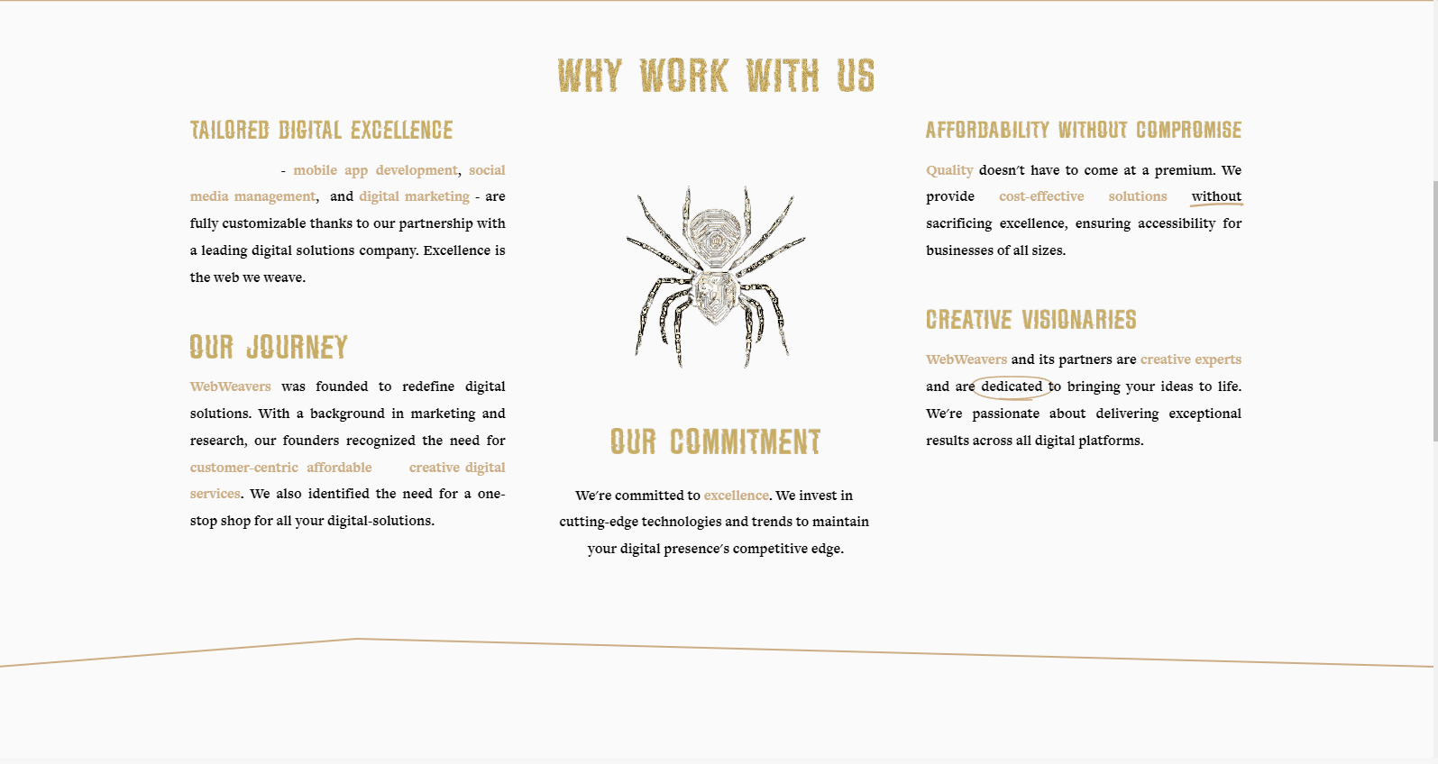

5 points to with space for text underneath it
- Tailored Digital Excellence
- Our Journey
- Our Commitment
- Creative Visionaries
- Affordability Without Compromise

FAQ Page
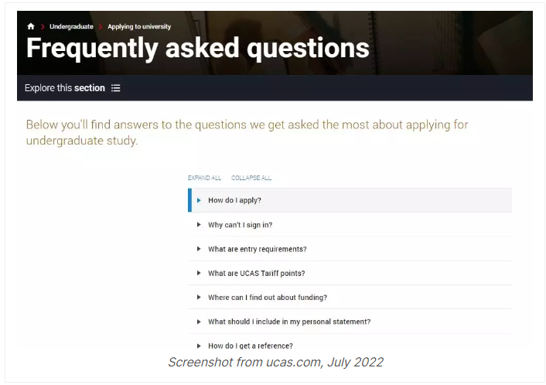

Contact Us –
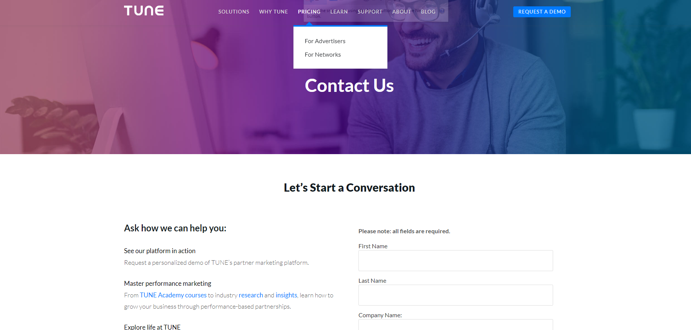

Text on both sides – Left for information, right for the client to fill out
Left side should have a header, and space for text.
Right side should have the following fields:
- First Name
- Last Name
- Company Name
- What type of solution are you looking for?
- Text box for the client to provide a description.

